**UPDATE TO THE KEYNOTE SPEAKERS!**

**We are excited to announce Northrop Grumman’s Travis Hedges Vice President, Supply Chain as the final keynote speaker for GPDIS 2024!**

PDES, Inc. is proud to announce their partnership with GPDIS**,** the premiere interoperability summit. The Global Product Data Interoperability Summit (GPDIS) is a place to build consensus on the data, tool, and process standards in a digital model-based environment based on the experience of liked minded professionals. The format is vendor-neutral, but all solution providers are encouraged to demonstrate both their technologies and their success stories.

The summit will be held September 23-26, 2024, in Phoenix, AZ. This year’s GPDIS theme is:

***Digital Engineering in the Model-Based Extended Enterprise***

The featured Keynote Speakers are:

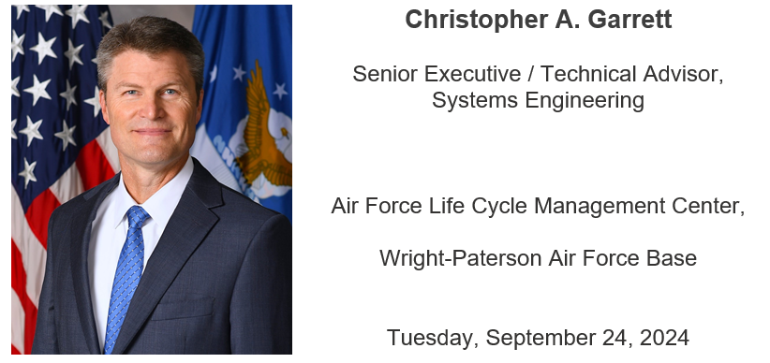



Click here to register for GPDIS 2024. [**Register Here**](https://gpdis.ticketbud.com/gpdis-2024-95262cc1-d0d9d042991f)and[**Book Your Hotel Here**](https://book.passkey.com/gt/219692021?gtid=62b71d660dbade9d36fd15dd1ad2f898)by August 21, 2024. Visit the [GPDIS website](https://gpdisonline.com/) for more information!

PDES is a member-based consortium that develops and implements model-based standards to support digital enterprises. The organization was founded in 1988 and includes Industry, Government, and Academia members. <https://pdesinc.org/>.

####